GetLost - SoloTravel & Travel Managing App

MINI PROJECT REPORT

Submitted by

DIVY JAIN [RA2311028010113]

Under the Guidance of

Dr. Nallarasan V

21CSC203P – ADVANCED PROGRAMMING PRACTICES

DEPARTMENT OF NETWORKING AND COMMUNICATION



FACULTY OF ENGINEERING AND TECHNOLOGY
SCHOOL OF COMPUTING
SRM INSTITUTE OF SCIENCE AND TECHNOLOGY

KATTANKULATHUR
NOVEMBER 2024

SRM INSTITUTION OF SCIENCE AND TECHNOLOGY
(Under Section 3 of UGC Act, 1956)

BONAFIDE CERTIFICATE

Certified that the 21CSC203P Advance Programming Practice course project report titled “GetLost - SoloTravel & Travel Managing App” is the bonafide work done by Divy Jain [RA2311028010113] of II Year/III Sem B.Tech(CSE-CC) who carried out the mini project under my supervision.

SIGNATURE
Faculty In-Charge Dr. Nallarasan V
Assistant Professor,
Department of Computational Intelligence, SRM Institute of Science and Technology Kattankulathur

SIGNATURE
Dr.Annie Uthra R

Head of the Department
Professor and Head
Department of Computational intelligence, SRM Institute of Science and Technology Kattankulathur

ABSTRACT

The Solo Travel App is an innovative application designed to empower individuals who prefer to explore new places independently. Developed using Java and enhanced with a user-friendly interface built with Swing, the app facilitates seamless travel planning by allowing users to create accounts, explore destinations, and connect with local guides or fellow solo travelers. With data securely managed in a MySQL database, the app ensures reliable storage and retrieval of user profiles, preferences, and travel histories.

In addition to basic trip planning features, the app provides unique tools such as AI-generated itinerary suggestions based on user interests, emergency contact features for safety, and community-based reviews for lodging and activities. Emphasizing both security and personalized experience, the Solo Travel App aims to make independent travel more accessible, enjoyable, and safe, demonstrating how technology can enrich solo travel adventures.

ACKNOWLEDGEMENT

We express our heartfelt thanks to our honourable Vice Chancellor Dr. C. MUTHAMIZHCHELVAN, for being the beacon in all our endeavours.
We would like to express my warmth of gratitude to our Registrar Dr. S Ponnusamy, for his encouragement.

We express our profound gratitude to our Dean (College of Engineering and Technology) Dr. T. V. Gopal, for bringing out novelty in all executions.
We would like to express my heartfelt thanks to Chairperson, School of Computing Dr. Revathi Venkataraman, for imparting confidence to complete my course project.

We wish to express my sincere thanks to Course Audit Professors Dr.
Vadivu. G, Professor, Department of Data Science and Business Systems and Dr. Sasikala. E Professor, Department of Data Science and Business Systems and Course Coordinators for their constant encouragement and support.

We are highly thankful to our Course project Faculty Faculty Name,
Assistant Professor, Department of Computational Intelligence, for her assistance, timely suggestion, and guidance throughout the duration of this course project.

We extend my gratitude to our HOD Dr. Annie Uthra R Professor and Head, Department of Computational Intelligence, and my Departmental colleagues for their Support.

Finally, we thank our parents and friends near and dear ones who directly and indirectly contributed to the successful completion of our project. Above all, I thank the almighty for showering his blessings on me to complete my Course project.

TABLE OF CONTENTS

Sr. No. | Title | Page No.
1. | Introduction | 6
2. | Literature Survey | 7
3. | Requirement Analysis | 7
4. | Architecture and Design | 9
5. | Implementation | 10
6. | Experiment Result and Analysis | 41
7. | Future Scope | 42
8. | Conclusion | 43
9. | References | 44

INTRODUCTION

The Solo Travel App is a cutting-edge application aimed at meeting the needs of solo travelers who seek independence, exploration, and a personalized travel experience. In recent years, solo travel has gained significant popularity, yet many travelers still face challenges in planning, safety, and finding trustworthy information tailored to their specific needs. This app is designed to address these challenges by providing an intuitive and secure platform that supports users in every stage of their journey—from planning and booking to real-time navigation and safety resources.

Developed with Java for robust functionality and featuring a user-friendly interface created with Swing, the app is built for ease of use. By integrating MySQL for secure data management, the Solo Travel App ensures that user profiles, trip histories, and preferences are securely stored and accessible. This app goes beyond basic travel planning; it incorporates AI-driven itinerary recommendations, local guide connections, and community reviews to offer a rich, engaging experience for solo travelers. With a commitment to security, user experience, and seamless functionality, the Solo Travel App aims to revolutionize solo travel by making it more enjoyable, safer, and accessible for adventurers around the world.

LITERATURE SURVEY

A literature survey for a GUI-based Travel System Project using Java and Swing involves reviewing relevant research and projects related to Travel systems, graphical user interface (GUI) development, and Java programming. Here is a comprehensive literature survey to provide insights into the context and requirements of such a project:

REQUIREMENT ANALYSIS

Requirement analysis for a GUI-based Solo Travel App Project using Java is essential to define the system's functionalities, features, and constraints, ensuring the app meets its objective of providing a secure, personalized, and enjoyable experience for solo travelers. This analysis establishes a foundation to guide development and ensures alignment with the core goals of user satisfaction, usability, and safety through an intuitive graphical user interface (GUI). Below is an outline of the functional and non-functional requirements, as well as system constraints.

Functional Requirements:

User Authentication and Security:
- Login Authentication: Users can sign up by creating a profile with personal details and travel preferences.
- Login with email and password or via social media accounts.
- Secure authentication to protect user data.

Travel Destination Exploration:
- Browse destinations by category, popularity, or user interests.
- Access to information on attractions, local events, and safety guidelines.

Itinerary Planning:
- Generate customized travel itineraries based on user preferences and destination data.
- Option to save and modify itineraries with activities, landmarks, and dining spots.

Local Guide and Community Connection:
- Connect with local guides or other travelers in the same area.
- In-app chat feature for planning and coordination.

Reviews and Recommendation:
- View and post reviews of destinations, accommodations, restaurants, and activities.
- Ratings to guide users in choosing quality experiences.

Database Management:

- Data Storage: The system must securely store user account details, profiles, bookings in a MySQL database.
- Real-time Updates: Database updates should occur instantly after each transaction to ensure accurate record-keeping.

Non-Functional Requirements:

Usability:
- Intuitive Interface: The GUI should be straightforward and easy to navigate, designed using Java Swing for familiar and responsive user interactions.
- Clear Notifications: Error messages and success notifications should be clear and provide guidance in case of incorrect inputs or transaction errors.

Performance:
- Efficiency: Transactions should complete within seconds to ensure a responsive user experience.
- Load Handling: The system should support concurrent users, handling transactions without significant performance degradation.

Reliability:
- Data Consistency: All transactions should be atomic, ensuring that data is consistently updated in the database, avoiding issues like partial updates or loss of data.

Security:
- Data Protection: All sensitive data, including PINs and transaction details, should be encrypted for storage and transmission.
- Multi-layered Authentication: The system should enforce multi-layered authentication, including OTP, especially for funds transfers, to enhance security.
- Logging and Monitoring: Transaction and error logs should be maintained to facilitate debugging and system monitoring.
- Data Privacy: The system should comply with data privacy standards to protect user information and maintain confidentiality.

System Constraints:

- While Java Swing is sufficient for basic GUI needs, more complex UI elements may require additional libraries or frameworks.
- For security, sessions should time out after a period of inactivity to prevent unauthorized access.
- The system is designed as a desktop application, so users will need a compatible device to access it.
- The system should enforce minimum security standards for PINs and passwords, ensuring a level of complexity.

ARCHITECTURE AND DESIGN

The Solo Travel App architecture is structured to provide a modular, secure, and user-friendly experience for travelers. The architecture consists of three primary layers: the Presentation Layer, Business Logic Layer, and Data Layer. These layers work together to ensure seamless interaction between the user interface, business processes, and data management, creating an efficient and secure system for users to explore destinations, plan trips, and connect with others. Below is a high-level architecture and design overview for the Solo Travel App project:

Architecture:

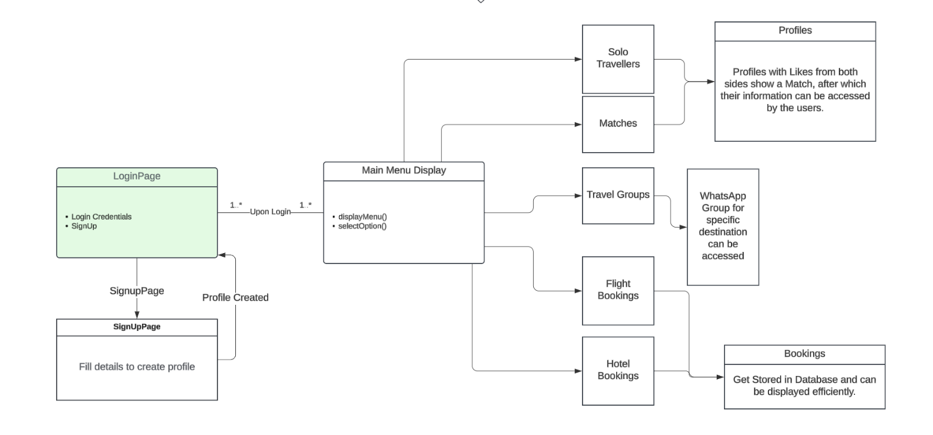

Architecture of the Project

• Presentation Layer: Java Swing GUI components (TinderLikePage.java, MatchesPage.java, etc)

• Business Logic Layer: Java classes and methods (Controller classes handling validation, profile showcase based on Destination.)

• Data Layer: MySQL database with tables for user information, profiles, likes, bookings for flights and hotels.

IMPLEMENTATION

To implement your Solo Travel App from scratch, follow these key steps:

1. Project Setup
- IDE and Tools: Set up your preferred Java IDE (like Visual Studio Code, IntelliJ, or Eclipse) for Java development.
- Database Setup:
- Install MySQL (or SQLite if you prefer).
- Create a new database for the Solo Travel App and create the necessary tables:
- users: to store user information (e.g., name, email, password, travel preferences).
- destinations: to store details about travel destinations (e.g., name, description, attractions).
- itineraries: to manage user-generated travel itineraries.
- reviews: to store user reviews and ratings for destinations, accommodations, and activities.
- Set up a JDBC connection in Java to interact with the MySQL database.

2. Frontend Design
- Login and Registration Pages:
- Create a simple GUI using Java Swing to prompt the user for registration or login.
- Add validation to ensure credentials meet security requirements (e.g., password strength).

- Home/Destination Exploration Page:
- Design an interface to browse or search for travel destinations by category, location, or user preferences.
- Display destination details, including descriptions, attractions, and user reviews.

- Itinerary Planning Screen:
- Allow users to create and customize their own travel itineraries by adding activities, landmarks, dining spots, and accommodations.
- Option to save and modify itineraries, with the data stored in the database.

- Local Guide and Community Connection Screen:
- Allow users to connect with local guides or other solo travelers in the same destination.
- Include an in-app chat feature for communication.

- Review and Recommendation Screen:
- Enable users to post reviews and ratings for destinations, accommodations, and activities.
- Display reviews from other users to help travelers make informed decisions.

- Expense Tracking Screen:
- Provide users with an interface to track their travel expenses.
- Display a breakdown of costs for accommodations, transportation, and activities.

- Safety and Emergency Contact Screen:
- Include an option to connect with emergency contacts and access local emergency numbers.
- Display real-time safety alerts for the selected destination.
3. Backend Logic
- Database Connection (JDBC):
- Implement a `Database Manager` class to establish and manage database interactions.
- Write methods for key functions like validating user login, retrieving destinations, saving itineraries, and storing reviews.

- Security:
- Use password hashing and secure OTP generation for user authentication.
- Encrypt sensitive user information stored in the database.

- Itinerary and Expense Logic:
- Implement logic to manage and save user-created itineraries, with options to modify or delete activities.
- Calculate expenses based on user inputs and provide budget insights.

- Local Guide and Messaging System:
- Develop a system for users to find and connect with local guides and communicate through in-app messaging.
- Allow users to block or report inappropriate interactions.

4. Additional Features
- User Profile Management:
- Enable users to update their personal information and travel preferences.
- Allow users to customize app settings, such as language and notification preferences.

- Review and Rating Filters:
- Implement sorting and filtering options for reviews, allowing users to view the most recent or highest-rated feedback.
- Display reviews with user ratings for clarity.

- User Interface Enhancements:
- Add custom themes, colors, and fonts to enhance the look and feel of the app.
- Implement responsive design elements for improved usability across devices.

5. Deployment
- Local Deployment:
- Deploy the Solo Travel App as a standalone desktop application that users can install on their computers.

- Future Enhancements:
- Consider expanding the system to integrate with external APIs for flight and hotel bookings, currency exchange rates, or weather updates.
- Add an AI-based recommendation engine to personalize destination suggestions based on travel history and preferences.

Following these steps will help you build a robust, user-friendly Solo Travel App that empowers users to plan and enjoy their solo travel experiences with ease.
Example of Basic Flow for the Solo Travel App:
- Login Page: The user enters their email and password. The system verifies the credentials and logs the user in.
- Home/Destination Exploration: Once logged in, the user is presented with a home screen showcasing various travel destinations. The user can browse or search for destinations by category or preferences.
- Destination Details: The user selects a destination to view detailed information, including attractions, accommodations, and local events. The user can also read reviews from other travelers.
- Itinerary Planning: The user adds activities, landmarks, and accommodations to create a customized itinerary for their trip. The itinerary is saved in the database for future reference or modification.
- Community and Guide Connection: The user opts to connect with local guides or other travelers in the destination area. They initiate a chat to plan meet-ups or receive travel tips.

Technologies and Tools:

- Java (Swing) for the frontend.
- MySQL for the backend database.
- JDBC to connect Java with MySQL.

CODE:

SoloTravelApp.java
import javax.swing.*;
import java.awt.*;
import java.awt.event.ActionEvent;
import java.awt.event.ActionListener;
import java.sql.*;

public class SoloTravelApp extends JFrame {
private int loggedInUserId; // Variable to store the logged-in user's ID

public SoloTravelApp() {
setTitle("Solo Travel App");
setSize(400, 300);
setDefaultCloseOperation(JFrame.EXIT_ON_CLOSE);

JPanel panel = new JPanel(new GridBagLayout());
GridBagConstraints gbc = new GridBagConstraints();
gbc.insets = new Insets(5, 5, 5, 5);

JTextField usernameField = new JTextField();
usernameField.setPreferredSize(new Dimension(200, 30));

JPasswordField passwordField = new JPasswordField();
passwordField.setPreferredSize(new Dimension(200, 30));

JButton loginButton = new JButton("Login");
JButton signUpButton = new JButton("Sign Up");

// Add components with layout
gbc.gridx = 0;
gbc.gridy = 0;
panel.add(new JLabel("Username:"), gbc);
gbc.gridx = 1;
panel.add(usernameField, gbc);

gbc.gridx = 0;
gbc.gridy = 1;
panel.add(new JLabel("Password:"), gbc);
gbc.gridx = 1;
panel.add(passwordField, gbc);

gbc.gridx = 0;
gbc.gridy = 2;
panel.add(loginButton, gbc);
gbc.gridx = 1;
panel.add(signUpButton, gbc);

add(panel);

// Login button action listener
loginButton.addActionListener(new ActionListener() {
public void actionPerformed(ActionEvent e) {
String username = usernameField.getText();
String password = new String(passwordField.getPassword());

if (authenticateUser(username, password)) {
loggedInUserId = getUserId(username, password); // Get the logged-in user's ID
if (loggedInUserId != -1) {
MainMenuPage mainMenu = new MainMenuPage(loggedInUserId); // Pass user ID to main menu
mainMenu.setVisible(true);
dispose();
} else {
JOptionPane.showMessageDialog(SoloTravelApp.this, "Error retrieving user ID.");
}
} else {
JOptionPane.showMessageDialog(SoloTravelApp.this, "Invalid username or password. Please try again.");
}
}
});

// Sign-up button action listener
signUpButton.addActionListener(new ActionListener() {
public void actionPerformed(ActionEvent e) {
new SignUpPage().setVisible(true);
}
});

setVisible(true);
}

// Function to authenticate user
private boolean authenticateUser(String username, String password) {
try (Connection conn = DatabaseManager.getConnection()) {
String query = "SELECT * FROM profiles WHERE username = ? AND password = ?";
PreparedStatement stmt = conn.prepareStatement(query);
stmt.setString(1, username);
stmt.setString(2, password);
ResultSet rs = stmt.executeQuery();
return rs.next(); // Returns true if a matching user is found
} catch (SQLException ex) {
ex.printStackTrace();
return false;
}
}

// Function to get user ID based on username and password
private int getUserId(String username, String password) {
int userId = -1; // Default value if no user is found
try (Connection conn = DatabaseManager.getConnection()) {
String query = "SELECT id FROM profiles WHERE username = ? AND password = ?";
PreparedStatement stmt = conn.prepareStatement(query);
stmt.setString(1, username);
stmt.setString(2, password);
ResultSet rs = stmt.executeQuery();
if (rs.next()) {
userId = rs.getInt("id"); // Fetch the user's ID if credentials match
}
} catch (SQLException ex) {
ex.printStackTrace();
}
return userId;
}

public static void main(String[] args) {
new SoloTravelApp();
}
}

import javax.swing.*;
import java.awt.*;
import java.sql.*;
import java.util.ArrayList;
import java.util.List;
import java.util.Random;

public class BookFlightsPage extends JFrame {
private int currentUserId;
private String destination;
private JComboBox<String> flightsDropdown;
private List<String> flights;

public BookFlightsPage(int currentUserId, String destination) {
this.currentUserId = currentUserId;
this.destination = destination;

setTitle("Available Flights to " + destination);
setSize(500, 350);
setDefaultCloseOperation(JFrame.DISPOSE_ON_CLOSE);
setLayout(new BorderLayout());

flights = generateFlights(destination);
flightsDropdown = new JComboBox<>(flights.toArray(new String[0]));
flightsDropdown.setFont(new Font("Arial", Font.PLAIN, 14));

JButton bookButton = new JButton("Book Selected Flight");
bookButton.setFont(new Font("Arial", Font.BOLD, 16));
bookButton.setBackground(new Color(0, 123, 255));
bookButton.setForeground(Color.WHITE);

JPanel topPanel = new JPanel(new FlowLayout(FlowLayout.CENTER, 10, 10));
topPanel.add(new JLabel("Select a Flight:"));
topPanel.add(flightsDropdown);

JPanel mainPanel = new JPanel();
mainPanel.setLayout(new BoxLayout(mainPanel, BoxLayout.Y_AXIS));
mainPanel.setBorder(BorderFactory.createEmptyBorder(20, 20, 20, 20));
mainPanel.add(topPanel);
mainPanel.add(Box.createVerticalStrut(20));
mainPanel.add(bookButton);

add(mainPanel, BorderLayout.CENTER);

bookButton.addActionListener(e -> bookFlight((String) flightsDropdown.getSelectedItem()));

setVisible(true);
}

private List<String> generateFlights(String destination) {
Random rand = new Random();
List<String> generatedFlights = new ArrayList<>();

for (int i = 0; i < 5; i++) {
String flightNumber = "FL" + (rand.nextInt(9000) + 1000);
String departureTime = (rand.nextInt(12) + 1) + ":" + (rand.nextInt(60)) + (rand.nextBoolean() ? " AM" : " PM");
int fare = (rand.nextInt(6) + 5) * 1000;

String flightDetails = "Flight: " + flightNumber + " | Time: " + departureTime + " | Fare: ₹" + fare;
generatedFlights.add(flightDetails);
}

return generatedFlights;
}

private void bookFlight(String selectedFlight) {
try (Connection conn = DatabaseManager.getConnection()) {
String insertQuery = "INSERT INTO bookings (user_id, destination, flight_details) VALUES (?, ?, ?)";
PreparedStatement stmt = conn.prepareStatement(insertQuery);
stmt.setInt(1, currentUserId);
stmt.setString(2, destination);
stmt.setString(3, selectedFlight);
stmt.executeUpdate();

JOptionPane.showMessageDialog(this, "Flight booked successfully!");
dispose();
} catch (SQLException ex) {
ex.printStackTrace();
JOptionPane.showMessageDialog(this, "Failed to book flight.", "Error", JOptionPane.ERROR_MESSAGE);
}
}
}

import javax.swing.*;
import java.awt.*;
import java.awt.event.ActionEvent;
import java.awt.event.ActionListener;
import java.sql.*;

public class BookHotelPage extends JFrame {
private int currentUserId;
private JComboBox<String> hotelDropdown;
private String selectedDestination;

public BookHotelPage(int currentUserId, String selectedDestination) {
this.currentUserId = currentUserId;
this.selectedDestination = selectedDestination;

setTitle("Book a Hotel");
setSize(400, 200);
setDefaultCloseOperation(JFrame.DISPOSE_ON_CLOSE);
setLayout(new BorderLayout());

hotelDropdown = new JComboBox<>();

loadHotels();

JButton bookHotelButton = new JButton("Book Hotel");

JPanel topPanel = new JPanel();
topPanel.add(new JLabel("Select Hotel:"));
topPanel.add(hotelDropdown);

add(topPanel, BorderLayout.CENTER);
add(bookHotelButton, BorderLayout.SOUTH);

bookHotelButton.addActionListener(new ActionListener() {
public void actionPerformed(ActionEvent e) {
String selectedHotel = (String) hotelDropdown.getSelectedItem();
if (selectedHotel != null) {
saveHotelBooking(selectedHotel);
}
}
});

setVisible(true);
}

private void loadHotels() {
// Generate hotels dynamically based on destination
String[] hotels = {
selectedDestination + " Grand Hotel",
selectedDestination + " City Inn",
selectedDestination + " Luxury Suites",
selectedDestination + " Budget Stay",
selectedDestination + " Premium Inn"
};

for (String hotel : hotels) {
hotelDropdown.addItem(hotel);
}
}

private void saveHotelBooking(String hotel) {
try (Connection conn = DatabaseManager.getConnection()) {
String query = "INSERT INTO hotel_bookings (user_id, destination, hotel_name, booking_date) VALUES (?, ?, ?, NOW())";
PreparedStatement stmt = conn.prepareStatement(query);
stmt.setInt(1, currentUserId);
stmt.setString(2, selectedDestination);
stmt.setString(3, hotel);
stmt.executeUpdate();

JOptionPane.showMessageDialog(this, "Hotel booked successfully!");

} catch (SQLException ex) {
ex.printStackTrace();
JOptionPane.showMessageDialog(this, "Failed to book hotel.", "Error", JOptionPane.ERROR_MESSAGE);
}
}
}

import javax.swing.*;
import java.awt.*;
import java.awt.event.ActionEvent;
import java.awt.event.ActionListener;
import java.sql.*;
import java.util.ArrayList;
import java.util.List;

public class CancelBookingPage extends JFrame {
private int currentUserId;
private JComboBox<String> bookingsDropdown;
private List<Integer> bookingIds;

public CancelBookingPage(int currentUserId) {
this.currentUserId = currentUserId;

setTitle("Cancel a Booking");
setSize(400, 200);
setDefaultCloseOperation(JFrame.DISPOSE_ON_CLOSE);
setLayout(new BorderLayout());

bookingIds = new ArrayList<>();
bookingsDropdown = new JComboBox<>();

loadBookings();

JButton cancelButton = new JButton("Cancel Selected Booking");

JPanel topPanel = new JPanel();
topPanel.add(new JLabel("Select Booking to Cancel:"));
topPanel.add(bookingsDropdown);

add(topPanel, BorderLayout.CENTER);
add(cancelButton, BorderLayout.SOUTH);

cancelButton.addActionListener(new ActionListener() {
public void actionPerformed(ActionEvent e) {
int selectedIndex = bookingsDropdown.getSelectedIndex();
if (selectedIndex >= 0) {
int bookingId = bookingIds.get(selectedIndex);
cancelBooking(bookingId);
}
}
});

setVisible(true);
}

private void loadBookings() {
try (Connection conn = DatabaseManager.getConnection()) {
String query = "SELECT booking_id, destination, flight_details, booking_date FROM bookings WHERE user_id = ?";
PreparedStatement stmt = conn.prepareStatement(query);
stmt.setInt(1, currentUserId);
ResultSet rs = stmt.executeQuery();

while (rs.next()) {
int bookingId = rs.getInt("booking_id");
String destination = rs.getString("destination");
String flightDetails = rs.getString("flight_details");
String bookingDate = rs.getString("booking_date");

bookingIds.add(bookingId);
bookingsDropdown.addItem("To " + destination + " | " + flightDetails + " | " + bookingDate);
}

if (bookingIds.isEmpty()) {
JOptionPane.showMessageDialog(this, "No bookings available to cancel.");
dispose();
}

} catch (SQLException ex) {
ex.printStackTrace();
}
}

private void cancelBooking(int bookingId) {
try (Connection conn = DatabaseManager.getConnection()) {
String deleteQuery = "DELETE FROM bookings WHERE booking_id = ?";
PreparedStatement stmt = conn.prepareStatement(deleteQuery);
stmt.setInt(1, bookingId);
stmt.executeUpdate();

JOptionPane.showMessageDialog(this, "Booking cancelled successfully!");

// Refresh the dropdown
bookingsDropdown.removeAllItems();
bookingIds.clear();
loadBookings();

} catch (SQLException ex) {
ex.printStackTrace();
JOptionPane.showMessageDialog(this, "Failed to cancel booking.", "Error", JOptionPane.ERROR_MESSAGE);
}
}
}

import javax.swing.*;
import java.awt.*;
import java.awt.event.ActionEvent;
import java.awt.event.ActionListener;
import java.sql.*;

public class CancelHotelBookingPage extends JFrame {
private int currentUserId;
private JComboBox<Integer> bookingDropdown;

public CancelHotelBookingPage(int currentUserId) {
this.currentUserId = currentUserId;

setTitle("Cancel Hotel Booking");
setSize(400, 200);
setDefaultCloseOperation(JFrame.DISPOSE_ON_CLOSE);
setLayout(new BorderLayout());

bookingDropdown = new JComboBox<>();
loadBookings();

JButton cancelButton = new JButton("Cancel Booking");
cancelButton.addActionListener(new ActionListener() {
public void actionPerformed(ActionEvent e) {
Integer selectedBookingId = (Integer) bookingDropdown.getSelectedItem();
if (selectedBookingId != null) {
cancelBooking(selectedBookingId);
}
}
});

JPanel panel = new JPanel();
panel.add(new JLabel("Select Booking ID to Cancel:"));
panel.add(bookingDropdown);

add(panel, BorderLayout.CENTER);
add(cancelButton, BorderLayout.SOUTH);

setVisible(true);
}

private void loadBookings() {
try (Connection conn = DatabaseManager.getConnection()) {
String query = "SELECT booking_id FROM hotel_bookings WHERE user_id = ?";
PreparedStatement stmt = conn.prepareStatement(query);
stmt.setInt(1, currentUserId);
ResultSet rs = stmt.executeQuery();

while (rs.next()) {
bookingDropdown.addItem(rs.getInt("booking_id"));
}
} catch (SQLException ex) {
ex.printStackTrace();
}
}

private void cancelBooking(int bookingId) {
try (Connection conn = DatabaseManager.getConnection()) {
String query = "DELETE FROM hotel_bookings WHERE booking_id = ?";
PreparedStatement stmt = conn.prepareStatement(query);
stmt.setInt(1, bookingId);
int rowsAffected = stmt.executeUpdate();

if (rowsAffected > 0) {
JOptionPane.showMessageDialog(this, "Booking canceled successfully.");
bookingDropdown.removeItem(bookingId); // Remove the canceled booking from the dropdown
} else {
JOptionPane.showMessageDialog(this, "Failed to cancel booking.", "Error", JOptionPane.ERROR_MESSAGE);
}
} catch (SQLException ex) {
ex.printStackTrace();
}
dispose();
}
}

DatabaseManager.java:

import java.sql.*;

public class DatabaseManager {
private static final String URL = "jdbc:mysql://localhost:3306/solo_travel_app";
private static final String USER = "root";
private static final String PASSWORD = "Aster@2405";

public static Connection getConnection() throws SQLException {
return DriverManager.getConnection(URL, USER, PASSWORD);
}

public static ResultSet getProfiles(String destination) throws SQLException {
Connection conn = getConnection();
String query = "SELECT * FROM profiles WHERE destination_city = ?";
PreparedStatement stmt = conn.prepareStatement(query);
stmt.setString(1, destination);
return stmt.executeQuery();
}

public static void saveLike(int userId, int likedUserId) throws SQLException {
Connection conn = getConnection();
String query = "INSERT INTO likes (user_id, liked_user_id) VALUES (?, ?)";
PreparedStatement stmt = conn.prepareStatement(query);
stmt.setInt(1, userId);
stmt.setInt(2, likedUserId);
stmt.executeUpdate();
}

public static ResultSet checkMatch(int userId, int likedUserId) throws SQLException {
Connection conn = getConnection();
String query = "SELECT * FROM likes WHERE user_id = ? AND liked_user_id = ?";
PreparedStatement stmt = conn.prepareStatement(query);
stmt.setInt(1, likedUserId);
stmt.setInt(2, userId);
return stmt.executeQuery();
}

public static ResultSet getMatches(int userId) throws SQLException {
Connection conn = getConnection();
String query = "SELECT p.name, p.email, p.phone FROM profiles p JOIN likes l ON p.id = l.liked_user_id " +
"WHERE l.user_id = ? AND EXISTS (SELECT * FROM likes WHERE user_id = p.id AND liked_user_id = ?)";
PreparedStatement stmt = conn.prepareStatement(query);
stmt.setInt(1, userId);
stmt.setInt(2, userId);
return stmt.executeQuery();
}

}

import javax.swing.*;
import java.awt.*;
import java.awt.event.ActionEvent;
import java.awt.event.ActionListener;

public class MainMenuPage extends JFrame {

public MainMenuPage(int currentUserId) {
setTitle("Main Menu");
setSize(600, 500);
setDefaultCloseOperation(JFrame.EXIT_ON_CLOSE);

// Set layout and padding
JPanel panel = new JPanel();
panel.setLayout(new BoxLayout(panel, BoxLayout.Y_AXIS));
panel.setBorder(BorderFactory.createEmptyBorder(20, 20, 20, 20));

// Add title label
JLabel titleLabel = new JLabel("Main Menu");
titleLabel.setFont(new Font("Arial", Font.BOLD, 24));
titleLabel.setAlignmentX(Component.CENTER_ALIGNMENT);
panel.add(titleLabel);

panel.add(Box.createVerticalStrut(20)); // Add spacing

// Destination Dropdown
JLabel destinationLabel = new JLabel("Select Destination:");
destinationLabel.setFont(new Font("Arial", Font.PLAIN, 16));
destinationLabel.setAlignmentX(Component.CENTER_ALIGNMENT);

String[] locations = {"Delhi", "Mumbai", "Bangalore", "Chennai", "Hyderabad", "Kolkata", "Pune", "Jaipur", "Ahmedabad"};
JComboBox<String> locationDropdown = new JComboBox<>(locations);
locationDropdown.setMaximumSize(new Dimension(200, 25));
locationDropdown.setAlignmentX(Component.CENTER_ALIGNMENT);

panel.add(destinationLabel);
panel.add(Box.createVerticalStrut(10)); // Spacing
panel.add(locationDropdown);

// Button panel with grid layout
JPanel buttonPanel = new JPanel();
buttonPanel.setLayout(new GridLayout(4, 2, 15, 15));
buttonPanel.setBorder(BorderFactory.createEmptyBorder(20, 0, 20, 0));

// Add buttons with styling
JButton soloTravellersButton = createButton("Solo Travellers");
JButton travelGroupsButton = createButton("Travel Groups");
JButton matchesButton = createButton("Matches");
JButton bookFlightsButton = createButton("Book Flights");
JButton showBookingsButton = createButton("Show Flight Bookings");
JButton bookHotelsButton = createButton("Book Hotels");
JButton showHotelsButton = createButton("Show Hotel Bookings");
JButton logoutButton = createButton("Logout");

// Add buttons to grid panel
buttonPanel.add(soloTravellersButton);
buttonPanel.add(travelGroupsButton);
buttonPanel.add(matchesButton);
buttonPanel.add(bookFlightsButton);
buttonPanel.add(showBookingsButton);
buttonPanel.add(bookHotelsButton);
buttonPanel.add(showHotelsButton);
buttonPanel.add(logoutButton);

panel.add(buttonPanel);

add(panel);

// Button action listeners
soloTravellersButton.addActionListener(new ActionListener() {
public void actionPerformed(ActionEvent e) {
String selectedLocation = (String) locationDropdown.getSelectedItem();
new TinderLikePage(selectedLocation, currentUserId).setVisible(true);
}
});

travelGroupsButton.addActionListener(new ActionListener() {
public void actionPerformed(ActionEvent e) {
String selectedLocation = (String) locationDropdown.getSelectedItem();
new QRimage(selectedLocation).setVisible(true); // Open QR Image based on location
}
});

matchesButton.addActionListener(new ActionListener() {
public void actionPerformed(ActionEvent e) {
new MatchesPage(currentUserId).setVisible(true);
}
});

bookFlightsButton.addActionListener(new ActionListener() {
public void actionPerformed(ActionEvent e) {
String selectedLocation = (String) locationDropdown.getSelectedItem();
new BookFlightsPage(currentUserId, selectedLocation).setVisible(true);
}
});

showBookingsButton.addActionListener(new ActionListener() {
public void actionPerformed(ActionEvent e) {
new ShowBookingsPage(currentUserId).setVisible(true);
}
});

bookHotelsButton.addActionListener(new ActionListener() {
public void actionPerformed(ActionEvent e) {
String selectedLocation = (String) locationDropdown.getSelectedItem();
new BookHotelPage(currentUserId, selectedLocation).setVisible(true);
}
});

showHotelsButton.addActionListener(new ActionListener() {
public void actionPerformed(ActionEvent e) {
new ShowHotelBookingsPage(currentUserId).setVisible(true);
}
});

logoutButton.addActionListener(new ActionListener() {
public void actionPerformed(ActionEvent e) {
dispose();
new SoloTravelApp().setVisible(true);
}
});

setLocationRelativeTo(null); // Center the frame
}

// Helper method to create styled buttons
private JButton createButton(String text) {
JButton button = new JButton(text);
button.setFont(new Font("Arial", Font.PLAIN, 14));
button.setPreferredSize(new Dimension(120, 40));
button.setFocusPainted(false);
return button;
}
}

import javax.swing.*;
import java.awt.*;
import java.sql.*;

public class MatchesPage extends JFrame {
private int loggedInUserId;

public MatchesPage(int loggedInUserId) {
this.loggedInUserId = loggedInUserId;

setTitle("Your Matches");
setSize(400, 300);
setDefaultCloseOperation(JFrame.DISPOSE_ON_CLOSE);
setLayout(new BorderLayout());

JPanel matchesPanel = new JPanel();
matchesPanel.setLayout(new BoxLayout(matchesPanel, BoxLayout.Y_AXIS));

loadMatches(matchesPanel);

add(new JScrollPane(matchesPanel), BorderLayout.CENTER);
setVisible(true);
}

private void loadMatches(JPanel panel) {
try (Connection conn = DatabaseManager.getConnection()) {
String query = "SELECT p.name, p.age, p.origin_city, p.destination_city, p.phone, p.email " +
"FROM profiles p " +
"JOIN likes l1 ON l1.target_user_id = p.id " +
"JOIN likes l2 ON l2.user_id = p.id AND l2.target_user_id = l1.user_id " +
"WHERE l1.user_id = ? AND l1.liked = TRUE AND l2.liked = TRUE";
PreparedStatement stmt = conn.prepareStatement(query);
stmt.setInt(1, loggedInUserId);
ResultSet rs = stmt.executeQuery();

if (!rs.isBeforeFirst()) { // Check if ResultSet is empty
panel.add(new JLabel("No matches yet. Like profiles to find matches!"));
} else {
while (rs.next()) {
String name = rs.getString("name");
int age = rs.getInt("age");
String originCity = rs.getString("origin_city");
String destinationCity = rs.getString("destination_city");
String phone = rs.getString("phone");
String email = rs.getString("email");

JLabel matchLabel = new JLabel(
"<html>" + name + ", " + age + " (" + originCity + " -> " + destinationCity + ")<br/>" +
"Phone: " + phone + "<br/>" +
"Email: " + email + "</html>"
);
panel.add(matchLabel);
}
}
} catch (SQLException ex) {
ex.printStackTrace();
}
}

}

import javax.swing.*;
import java.awt.*;
import java.util.HashMap;
import java.util.Map;

public class QRimage extends JFrame {
private Map<String, String> qrImagePaths;

public QRimage(String destination) {
setTitle("QR Code for " + destination);
setSize(400, 700);
setDefaultCloseOperation(JFrame.DISPOSE_ON_CLOSE);

qrImagePaths = new HashMap<>();
qrImagePaths.put("Delhi", "lib\\DelhiQR.jpg");
qrImagePaths.put("Mumbai", "lib\\MumbaiQR.jpg");
qrImagePaths.put("Bangalore", "lib\\BangaloreQR.jpg");
qrImagePaths.put("Chennai", "lib\\ChennaiQR.jpg");

JLabel qrLabel = new JLabel();
ImageIcon qrIcon = loadQRImage(destination);
qrLabel.setIcon(qrIcon);
add(qrLabel);
}

private ImageIcon loadQRImage(String destination) {
String imagePath = qrImagePaths.getOrDefault(destination, "path/to/defaultQR.jpg");
ImageIcon icon = new ImageIcon(imagePath);
Image img = icon.getImage().getScaledInstance(400, 700, Image.SCALE_SMOOTH);
return new ImageIcon(img);
}
}

import javax.swing.*;
import java.awt.*;
import java.awt.event.ActionEvent;
import java.awt.event.ActionListener;
import java.sql.*;

public class ShowBookingsPage extends JFrame {
private int currentUserId;

public ShowBookingsPage(int currentUserId) {
this.currentUserId = currentUserId;

setTitle("Your Bookings");
setSize(400, 300);
setDefaultCloseOperation(JFrame.DISPOSE_ON_CLOSE);
setLayout(new BorderLayout());

JPanel bookingsPanel = new JPanel();
bookingsPanel.setLayout(new BoxLayout(bookingsPanel, BoxLayout.Y_AXIS));

loadBookings(bookingsPanel);

JButton cancelBookingsButton = new JButton("Cancel Bookings");
cancelBookingsButton.addActionListener(new ActionListener() {
public void actionPerformed(ActionEvent e) {
new CancelBookingPage(currentUserId).setVisible(true);
dispose();
}
});
JPanel bottomPanel = new JPanel();
bottomPanel.add(cancelBookingsButton);

add(new JScrollPane(bookingsPanel), BorderLayout.CENTER);
add(bottomPanel, BorderLayout.SOUTH);
setVisible(true);
}

private void loadBookings(JPanel panel) {
try (Connection conn = DatabaseManager.getConnection()) {
String query = "SELECT destination, flight_details, booking_date FROM bookings WHERE user_id = ?";
PreparedStatement stmt = conn.prepareStatement(query);
stmt.setInt(1, currentUserId);
ResultSet rs = stmt.executeQuery();

if (!rs.isBeforeFirst()) { // Check if ResultSet is empty
panel.add(new JLabel("No bookings found."));
dispose();
} else {
while (rs.next()) {
String destination = rs.getString("destination");
String flightDetails = rs.getString("flight_details");
String bookingDate = rs.getString("booking_date");

JLabel bookingLabel = new JLabel(
"<html>Destination: " + destination +
"<br>Flight Details: " + flightDetails +
"<br>Booked On: " + bookingDate + "<br><br></html>"
);
panel.add(bookingLabel);
}
}
} catch (SQLException ex) {
ex.printStackTrace();
}
dispose();
}
}

import javax.swing.*;
import java.awt.*;
import java.awt.event.ActionEvent;
import java.awt.event.ActionListener;
import java.sql.*;

public class ShowHotelBookingsPage extends JFrame {
private int currentUserId;

public ShowHotelBookingsPage(int currentUserId) {
this.currentUserId = currentUserId;

setTitle("Your Hotel Bookings");
setSize(500, 400);
setDefaultCloseOperation(JFrame.DISPOSE_ON_CLOSE);
setLayout(new BorderLayout());

JPanel bookingsPanel = new JPanel();
bookingsPanel.setLayout(new BoxLayout(bookingsPanel, BoxLayout.Y_AXIS));

loadHotelBookings(bookingsPanel);

JButton cancelBookingButton = new JButton("Cancel Booking");
cancelBookingButton.addActionListener(new ActionListener() {
public void actionPerformed(ActionEvent e) {
new CancelHotelBookingPage(currentUserId).setVisible(true);
dispose();
}
});

add(new JScrollPane(bookingsPanel), BorderLayout.CENTER);
add(cancelBookingButton, BorderLayout.SOUTH);

setVisible(true);
}

private void loadHotelBookings(JPanel panel) {
try (Connection conn = DatabaseManager.getConnection()) {
String query = "SELECT booking_id, destination, hotel_name, booking_date FROM hotel_bookings WHERE user_id = ?";
PreparedStatement stmt = conn.prepareStatement(query);
stmt.setInt(1, currentUserId);
ResultSet rs = stmt.executeQuery();

if (!rs.isBeforeFirst()) {
panel.add(new JLabel("No hotel bookings found."));
} else {
while (rs.next()) {
int bookingId = rs.getInt("booking_id");
String destination = rs.getString("destination");
String hotelName = rs.getString("hotel_name");
String bookingDate = rs.getString("booking_date");

JLabel bookingLabel = new JLabel(
"<html>Booking ID: " + bookingId +
"<br>Destination: " + destination +
"<br>Hotel: " + hotelName +
"<br>Booked On: " + bookingDate + "<br><br></html>"
);
panel.add(bookingLabel);
}
}
} catch (SQLException ex) {
ex.printStackTrace();
}
}
}

import javax.swing.*;
import java.awt.*;
import java.awt.event.ActionEvent;
import java.awt.event.ActionListener;
import java.sql.Connection;
import java.sql.PreparedStatement;
import java.sql.SQLException;

public class SignUpPage extends JFrame {
public SignUpPage() {
setTitle("Sign Up");
setSize(400, 400);
setDefaultCloseOperation(JFrame.DISPOSE_ON_CLOSE);

JPanel panel = new JPanel(new GridBagLayout());
GridBagConstraints gbc = new GridBagConstraints();
gbc.insets = new Insets(5, 5, 5, 5);

JTextField nameField = new JTextField();
JTextField ageField = new JTextField();
JTextField originField = new JTextField();
JTextField destinationField = new JTextField();
JTextField emailField = new JTextField();
JTextField phoneField = new JTextField();
JTextField usernameField = new JTextField(); // Username field
JPasswordField passwordField = new JPasswordField();

nameField.setPreferredSize(new Dimension(200, 30));
ageField.setPreferredSize(new Dimension(200, 30));
originField.setPreferredSize(new Dimension(200, 30));
destinationField.setPreferredSize(new Dimension(200, 30));
emailField.setPreferredSize(new Dimension(200, 30));
phoneField.setPreferredSize(new Dimension(200, 30));
usernameField.setPreferredSize(new Dimension(200, 30));
passwordField.setPreferredSize(new Dimension(200, 30));

JButton registerButton = new JButton("Register");

String[] labels = {"Name:", "Age:", "Origin City:", "Destination City:", "Email:", "Phone:", "Username:", "Password:"};
JTextField[] fields = {nameField, ageField, originField, destinationField, emailField, phoneField, usernameField, passwordField};

for (int i = 0; i < labels.length; i++) {
gbc.gridx = 0;
gbc.gridy = i;
panel.add(new JLabel(labels[i]), gbc);

gbc.gridx = 1;
panel.add(fields[i], gbc);
}

gbc.gridx = 1;
gbc.gridy = labels.length;
panel.add(registerButton, gbc);

add(panel);

// Register button action listener
registerButton.addActionListener(new ActionListener() {
public void actionPerformed(ActionEvent e) {
String name = nameField.getText();
int age = Integer.parseInt(ageField.getText());
String originCity = originField.getText();
String destinationCity = destinationField.getText();
String email = emailField.getText();
String phone = phoneField.getText();
String username = usernameField.getText(); // Retrieve username
String password = new String(passwordField.getPassword());

try {
registerUser(name, age, originCity, destinationCity, email, phone, username, password);
JOptionPane.showMessageDialog(SignUpPage.this, "Registration Successful!");
dispose();
} catch (SQLException ex) {
ex.printStackTrace();
JOptionPane.showMessageDialog(SignUpPage.this, "Error registering user.");
}
}
});
}

// Register user in the database
private void registerUser(String name, int age, String originCity, String destinationCity, String email, String phone, String username, String password) throws SQLException {
Connection conn = DatabaseManager.getConnection();
String query = "INSERT INTO profiles (name, age, origin_city, destination_city, email, phone, username, password) VALUES (?, ?, ?, ?, ?, ?, ?, ?)";
PreparedStatement stmt = conn.prepareStatement(query);
stmt.setString(1, name);
stmt.setInt(2, age);
stmt.setString(3, originCity);
stmt.setString(4, destinationCity);
stmt.setString(5, email);
stmt.setString(6, phone);
stmt.setString(7, username); // Insert username
stmt.setString(8, password); // Insert password
stmt.executeUpdate();
}
}

import javax.swing.*;
import java.awt.*;
import java.sql.*;
import java.util.ArrayList;
import java.util.List;

public class TinderLikePage extends JFrame {
private int loggedInUserId;
private List<Profile> profiles;
private int currentIndex;
private JLabel profileInfoLabel;

public TinderLikePage(String location, int loggedInUserId) {
this.loggedInUserId = loggedInUserId;
this.profiles = new ArrayList<>();
this.currentIndex = 0;

setTitle("Tinder-like Solo Travelers");
setSize(450, 300);
setLocationRelativeTo(null); // Center the window on screen
setDefaultCloseOperation(JFrame.DISPOSE_ON_CLOSE);
setLayout(new BorderLayout(10, 10));

// Profile display area
profileInfoLabel = new JLabel("Loading profiles...", SwingConstants.CENTER);
profileInfoLabel.setFont(new Font("SansSerif", Font.BOLD, 18));
profileInfoLabel.setBorder(BorderFactory.createEmptyBorder(20, 10, 20, 10));
profileInfoLabel.setForeground(new Color(54, 81, 207));

// Buttons
JButton likeButton = new JButton("❤️ Like");
JButton dislikeButton = new JButton("👎 Dislike");
styleButton(likeButton);
styleButton(dislikeButton);

// Panels
JPanel profilePanel = new JPanel();
profilePanel.setLayout(new BorderLayout());
profilePanel.add(profileInfoLabel, BorderLayout.CENTER);

JPanel buttonPanel = new JPanel();
buttonPanel.setLayout(new GridLayout(1, 2, 10, 0));
buttonPanel.add(likeButton);
buttonPanel.add(dislikeButton);
buttonPanel.setBorder(BorderFactory.createEmptyBorder(0, 20, 20, 20));

add(profilePanel, BorderLayout.CENTER);
add(buttonPanel, BorderLayout.SOUTH);

likeButton.addActionListener(e -> handleLikeDislike(true));
dislikeButton.addActionListener(e -> handleLikeDislike(false));

loadProfiles(location);
displayCurrentProfile();
}

private void styleButton(JButton button) {
button.setFont(new Font("SansSerif", Font.PLAIN, 16));
button.setForeground(Color.WHITE);
button.setBackground(new Color(85, 107, 47));
button.setFocusPainted(false);
button.setBorder(BorderFactory.createLineBorder(new Color(70, 130, 180), 2));
button.setCursor(new Cursor(Cursor.HAND_CURSOR));
}

private void loadProfiles(String location) {
try (Connection conn = DatabaseManager.getConnection()) {
String query = "SELECT id, name, age, origin_city, destination_city FROM profiles WHERE destination_city = ? AND id != ?";
PreparedStatement stmt = conn.prepareStatement(query);
stmt.setString(1, location);
stmt.setInt(2, loggedInUserId);
ResultSet rs = stmt.executeQuery();

while (rs.next()) {
int id = rs.getInt("id");
String name = rs.getString("name");
int age = rs.getInt("age");
String originCity = rs.getString("origin_city");
String destinationCity = rs.getString("destination_city");
profiles.add(new Profile(id, name, age, originCity, destinationCity));
}
} catch (SQLException ex) {
ex.printStackTrace();
}
}

private void displayCurrentProfile() {
if (currentIndex < profiles.size()) {
Profile currentProfile = profiles.get(currentIndex);
profileInfoLabel.setText(
"<html><div style='text-align: center;'>" +
currentProfile.name + ", " + currentProfile.age +
"<br>(" + currentProfile.originCity + " ➔ " + currentProfile.destinationCity + ")" +
"</div></html>");
} else {
profileInfoLabel.setText("No more profiles available.");
}
}

private void handleLikeDislike(boolean liked) {
if (currentIndex < profiles.size()) {
Profile currentProfile = profiles.get(currentIndex);
saveLikeOrDislike(currentProfile.id, liked);
currentIndex++;
displayCurrentProfile();
}
}

private void saveLikeOrDislike(int targetUserId, boolean liked) {
try (Connection conn = DatabaseManager.getConnection()) {
String query = "INSERT INTO likes (user_id, target_user_id, liked) VALUES (?, ?, ?) " +
"ON DUPLICATE KEY UPDATE liked = ?";
PreparedStatement stmt = conn.prepareStatement(query);
stmt.setInt(1, loggedInUserId);
stmt.setInt(2, targetUserId);
stmt.setBoolean(3, liked);
stmt.setBoolean(4, liked);
stmt.executeUpdate();

if (liked && checkMutualLike(targetUserId)) {
JOptionPane.showMessageDialog(this, "It's a match! 🎉");
}
} catch (SQLException ex) {
ex.printStackTrace();
}
}

private boolean checkMutualLike(int targetUserId) {
try (Connection conn = DatabaseManager.getConnection()) {
String query = "SELECT * FROM likes WHERE user_id = ? AND target_user_id = ? AND liked = TRUE";
PreparedStatement stmt = conn.prepareStatement(query);
stmt.setInt(1, targetUserId);
stmt.setInt(2, loggedInUserId);
ResultSet rs = stmt.executeQuery();
return rs.next();
} catch (SQLException ex) {
ex.printStackTrace();
return false;
}
}

private class Profile {
int id;
String name;
int age;
String originCity;
String destinationCity;

Profile(int id, String name, int age, String originCity, String destinationCity) {
this.id = id;
this.name = name;
this.age = age;
this.originCity = originCity;
this.destinationCity = destinationCity;
}
}
}

OUTPUT:

    - DATABASE DESIGN
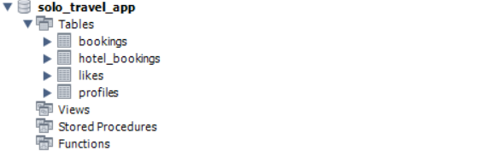

- LOGIN PAGE

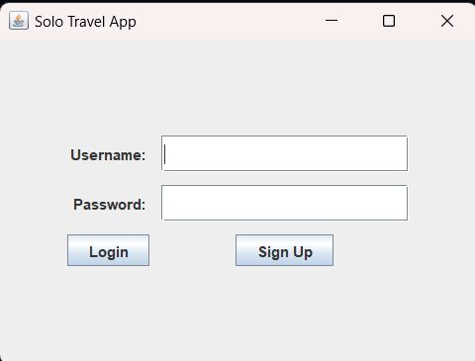

    - GUI DESIGN

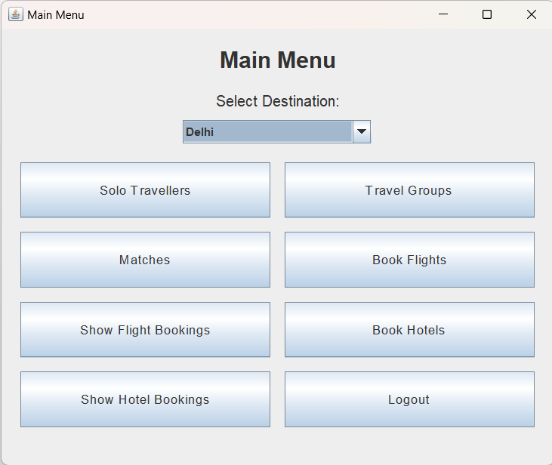

    - Sign Up Page
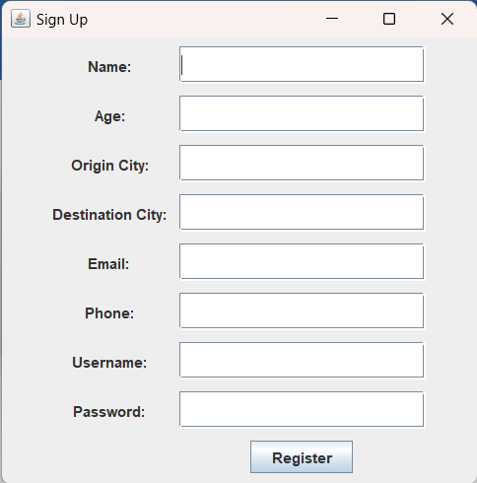

    - Solo Travelling

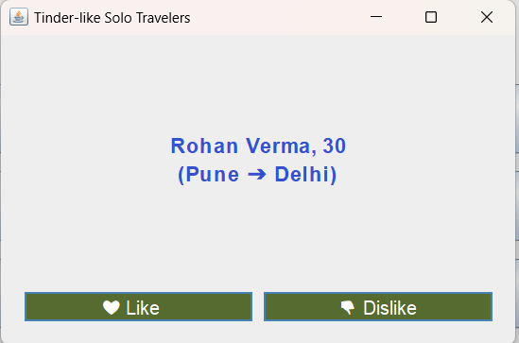

    - Travel Groups

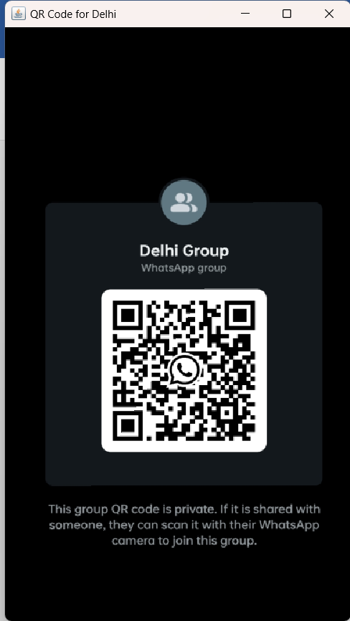

    - MATCHES

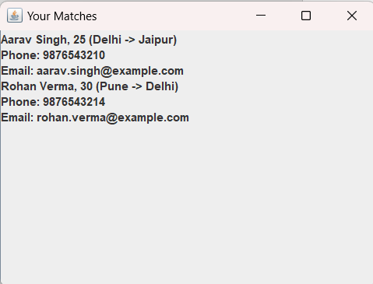

    - Flight Booking

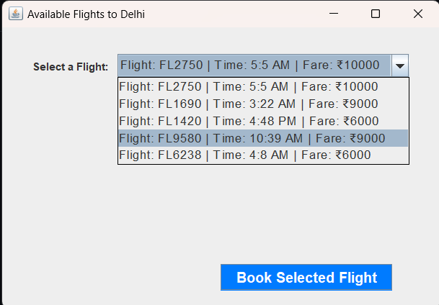

    - Hotel Booking

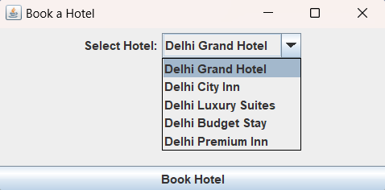

EXPERIMENTAL RESULTS AND ANALYSIS

Usability Evaluation:

User Satisfaction Survey: System Performance Evaluation: Data Collection and Analysis:

FUTURE SCOPE

The Solo Travel App has immense potential for future development to cater to the evolving needs of solo travelers. Planned enhancements include AI-based personalization for smarter itineraries and real-time alerts, API integrations for booking flights and accommodations, and community-driven features like group travel options and user-generated content. Integrating AR for navigation and landmark discovery, advanced safety measures such as travel insurance options, and offline functionality will provide users with an immersive and secure experience. Additionally, gamification, eco-friendly travel suggestions, multilingual support, and machine learning for budget predictions will further enrich the app, making it a comprehensive platform that anticipates travel needs and trends.

CONCLUSION

The Solo Travel App is designed to be more than just a travel planner; it aims to be a trusted companion for solo travelers, enabling exploration with confidence and convenience. By addressing key areas such as personalization, safety, and community engagement, the app is positioned to transform solo travel into an accessible, fulfilling experience. With continuous improvements and feature expansions, the Solo Travel App can lead the market, serving as a pioneering solution that adapts to the demands of modern travelers.

REFERENCES

- Java Swing Tutorial: Oracle's official documentation on creating graphical user interfaces with Swing.

- SQL Database Design: Tutorials on designing tables, relationships, and queries for an ATM system.

